**Fatima Jinnah Women University**

Department of Software Engineering

**LAB 1**

**Name:** Raifa Khalid

**Reg. no:** 2020-BSE-024

**Section:** A

**Semester:** Fourth

**Course:** Data Base (LAB)

TASK 01

1. Create a table named “SALESPERSON” consisting of following fields.

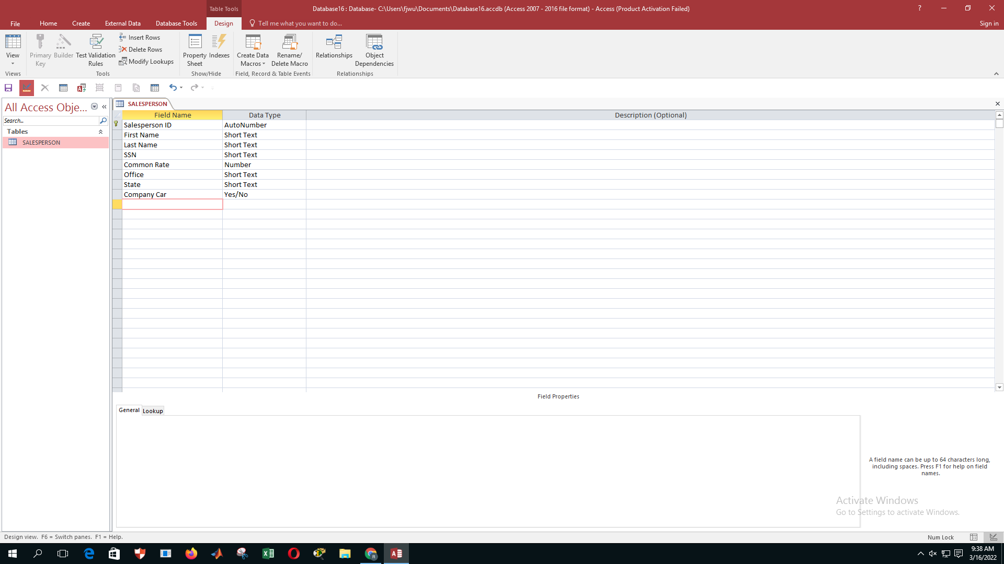

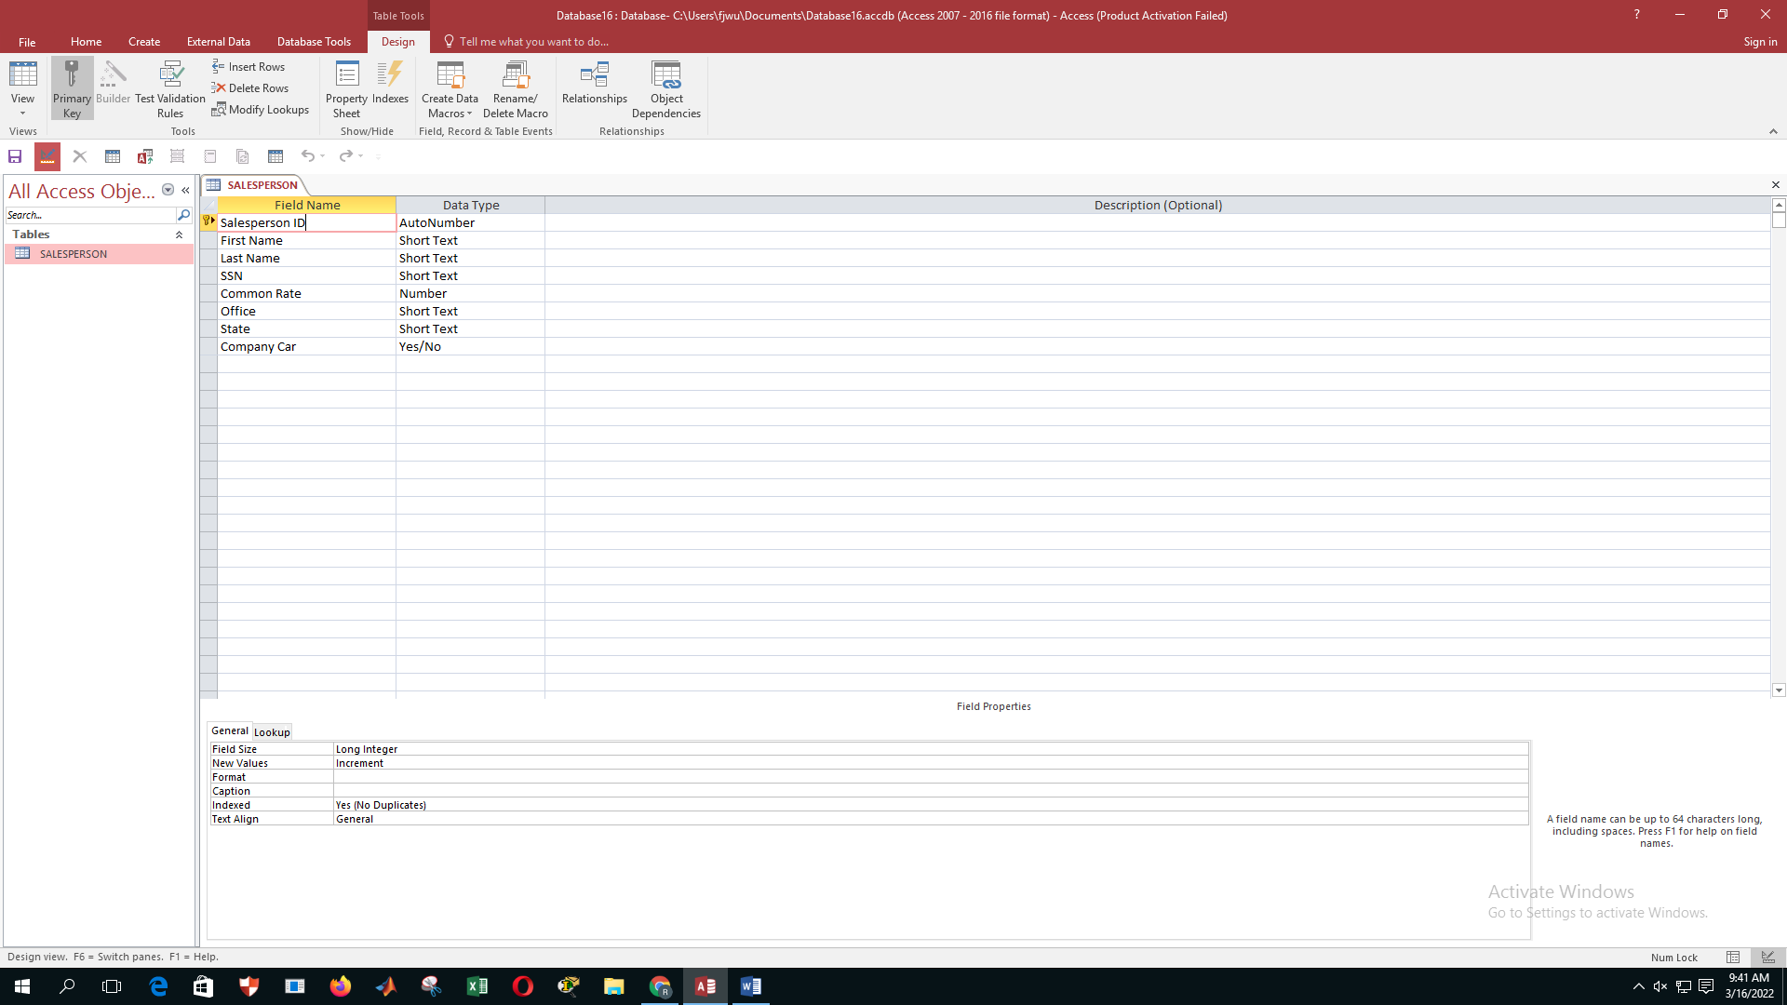

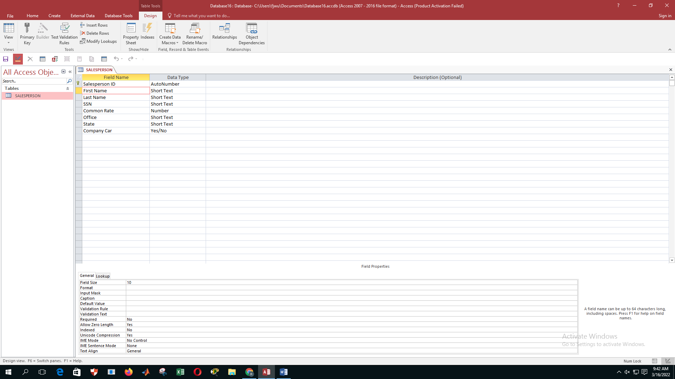

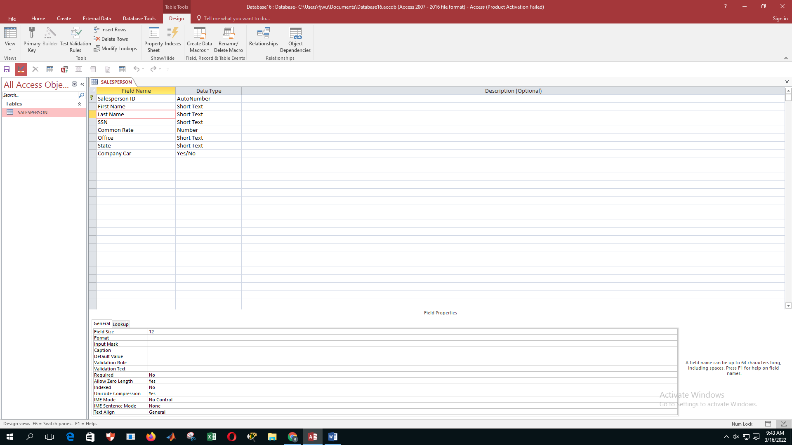

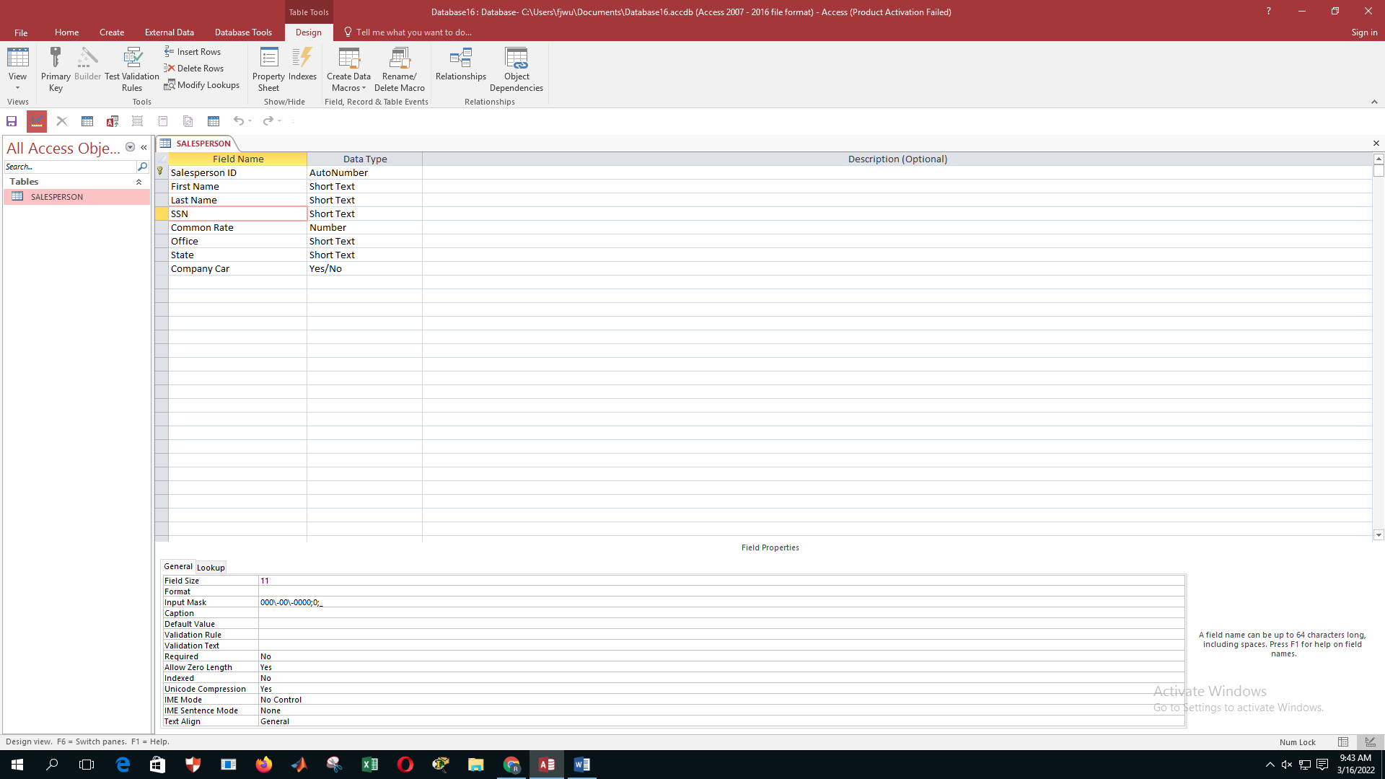

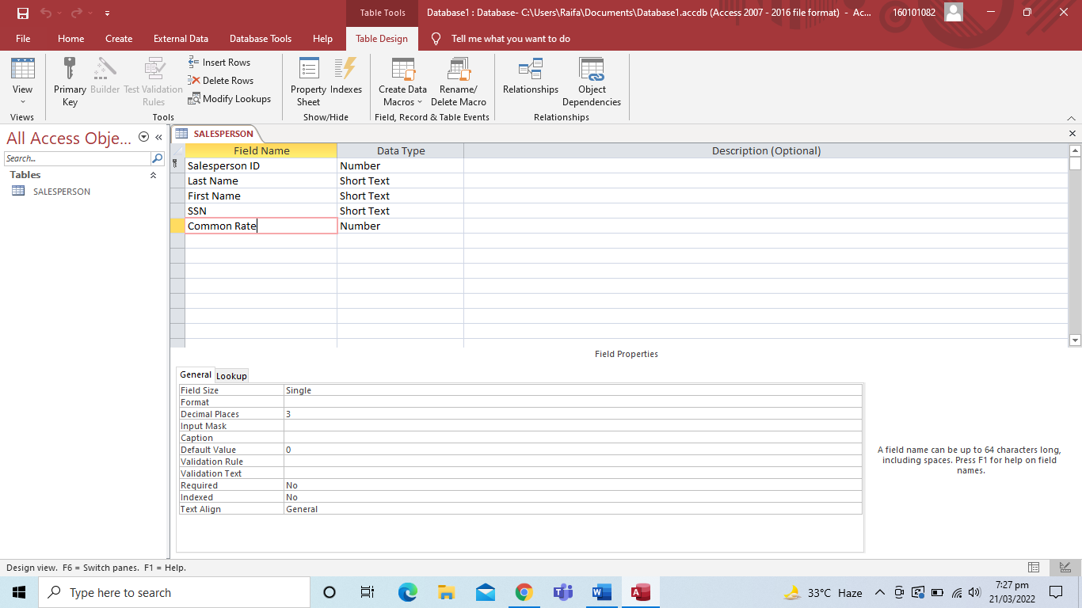

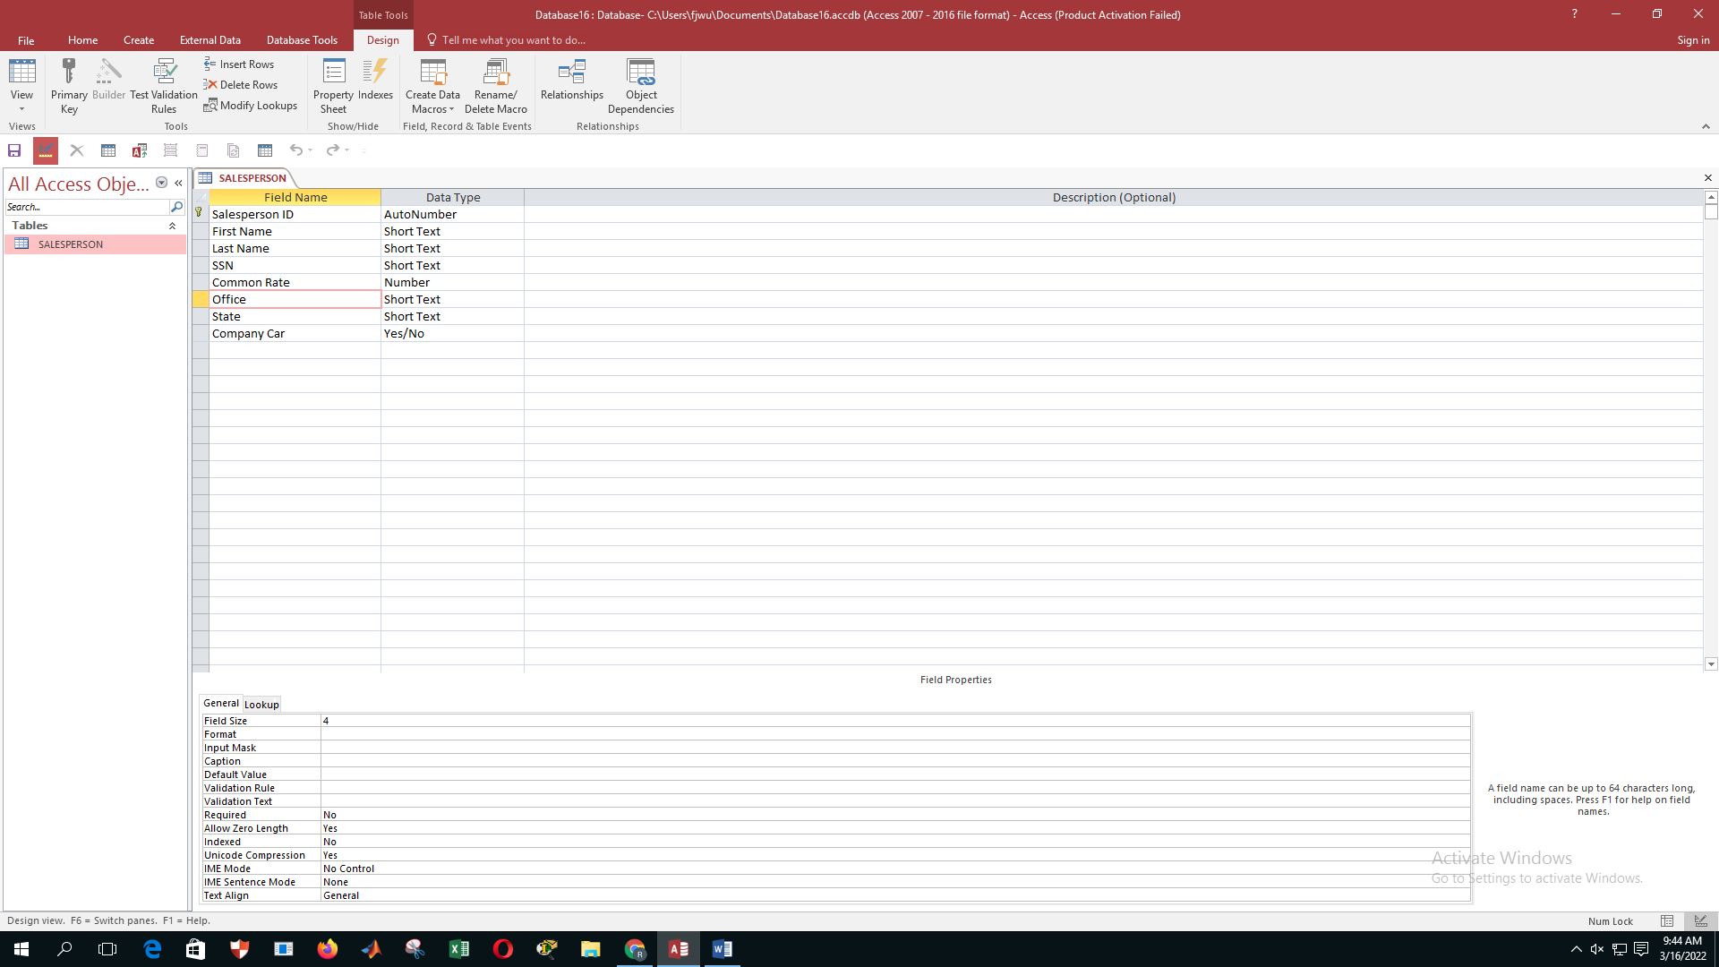

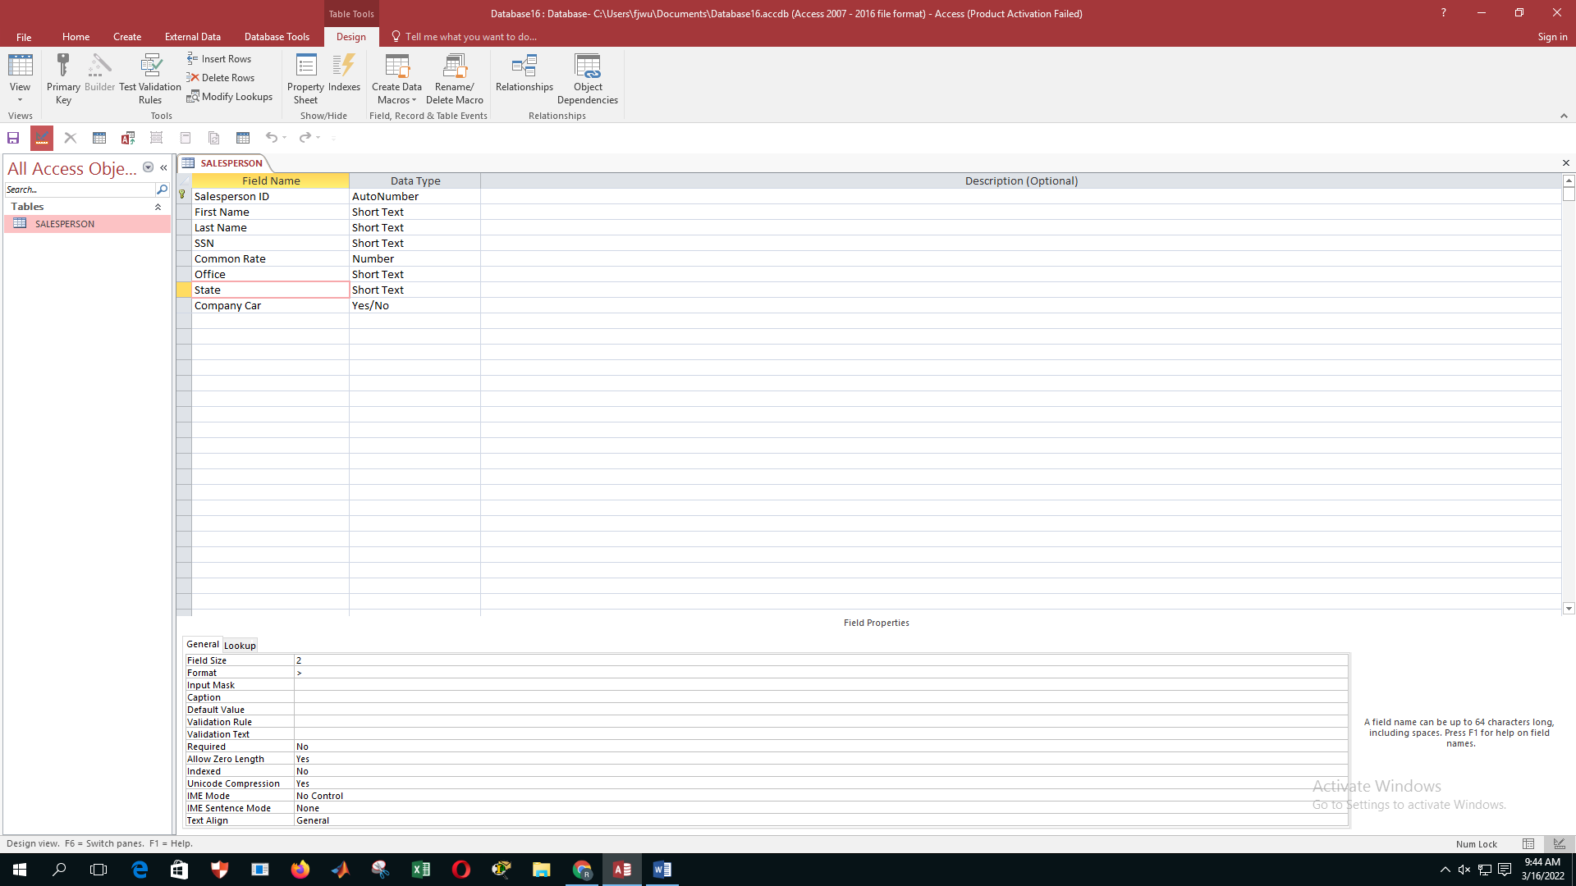

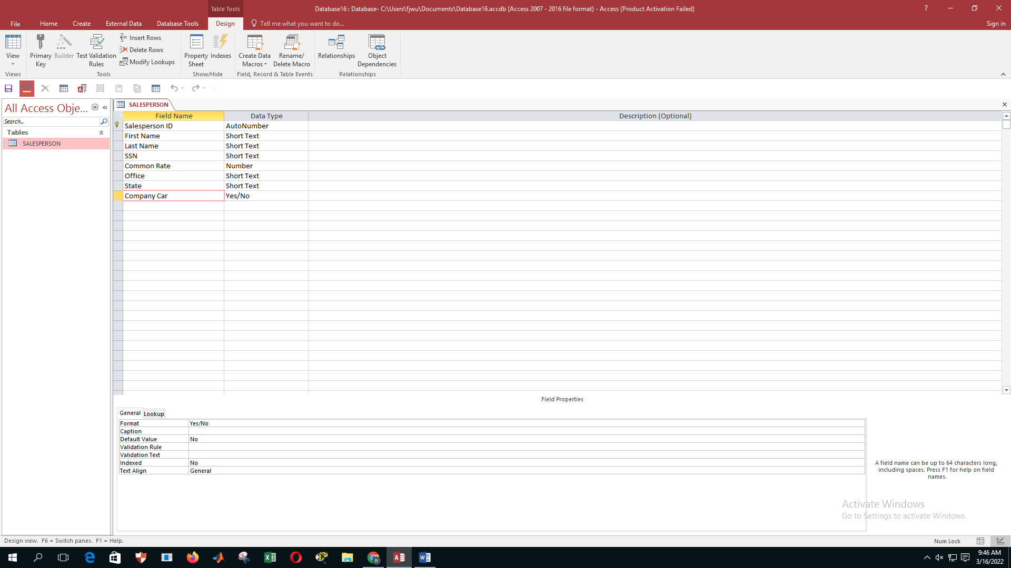

1. Create a table named “CUSTOMER” made up of following fields

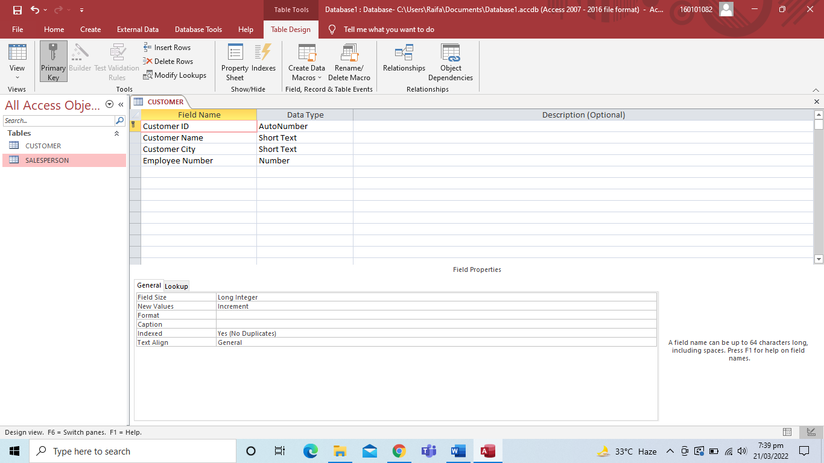

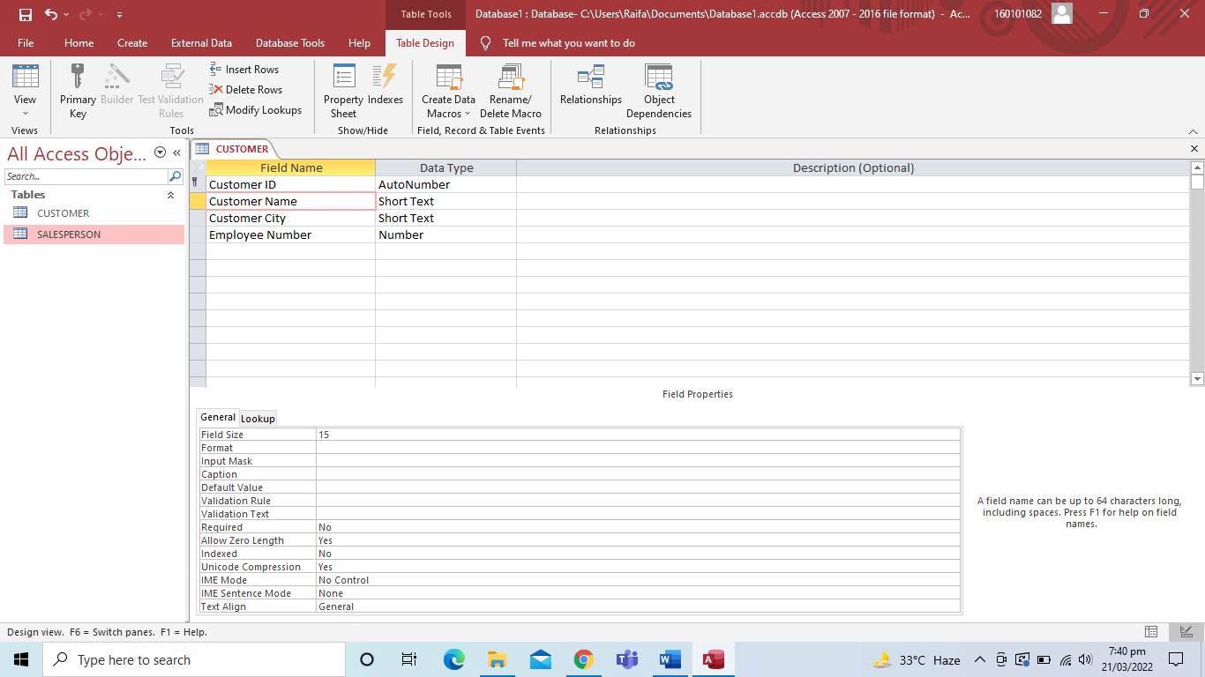

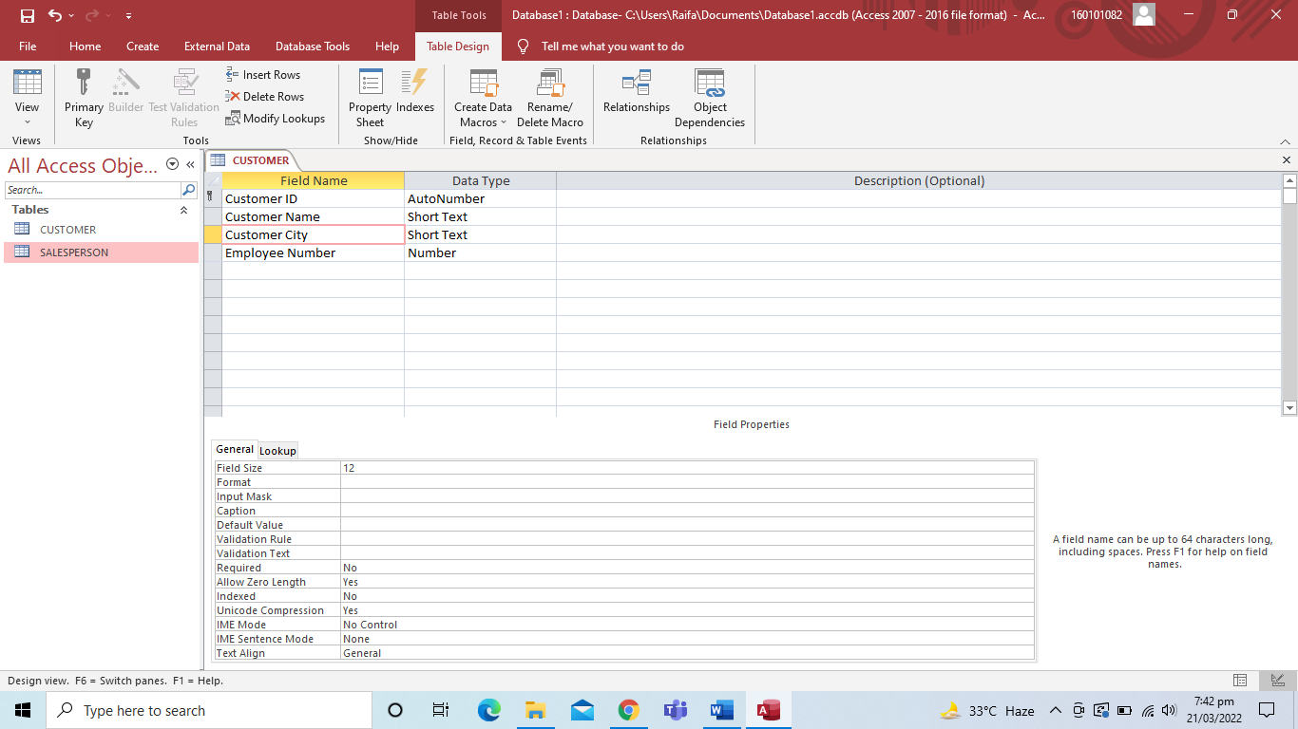

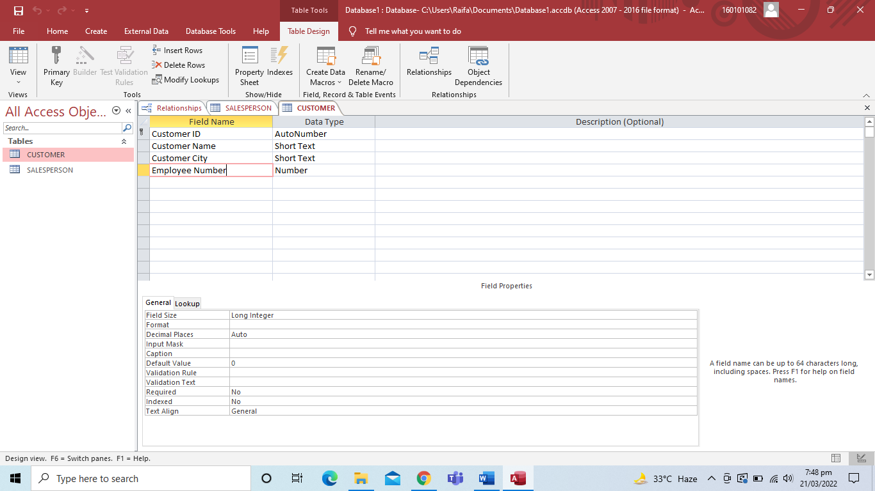

1. Create the relationship between the tables created above and also make sure “Enforcement of referential Integrity”.

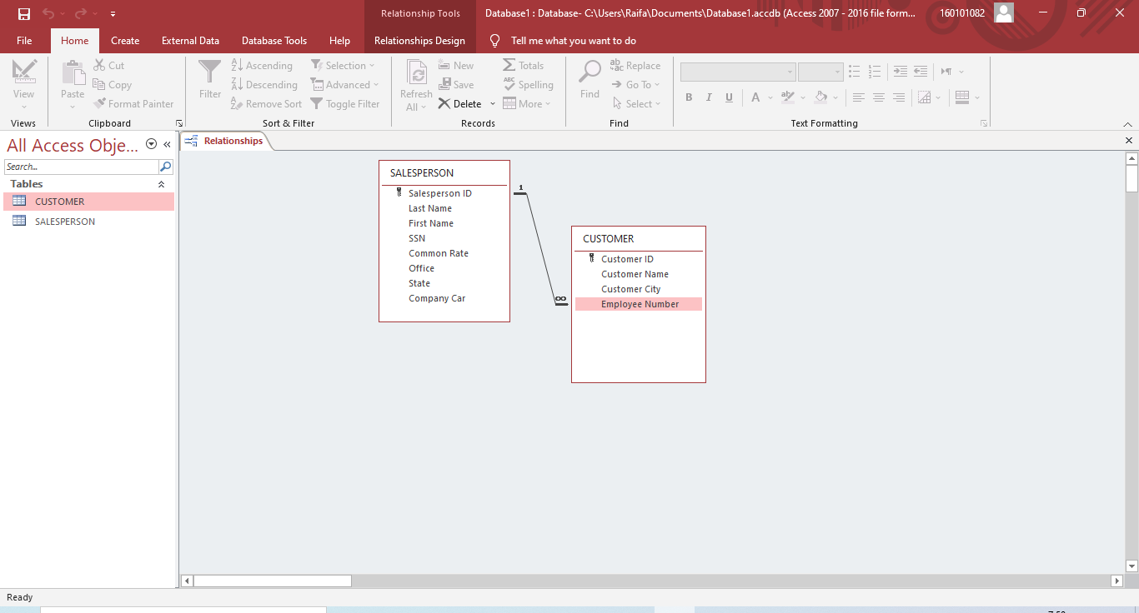

1. Insert the data in the above two tables
2. Best Fit all column widths and take a screenshot of print preview

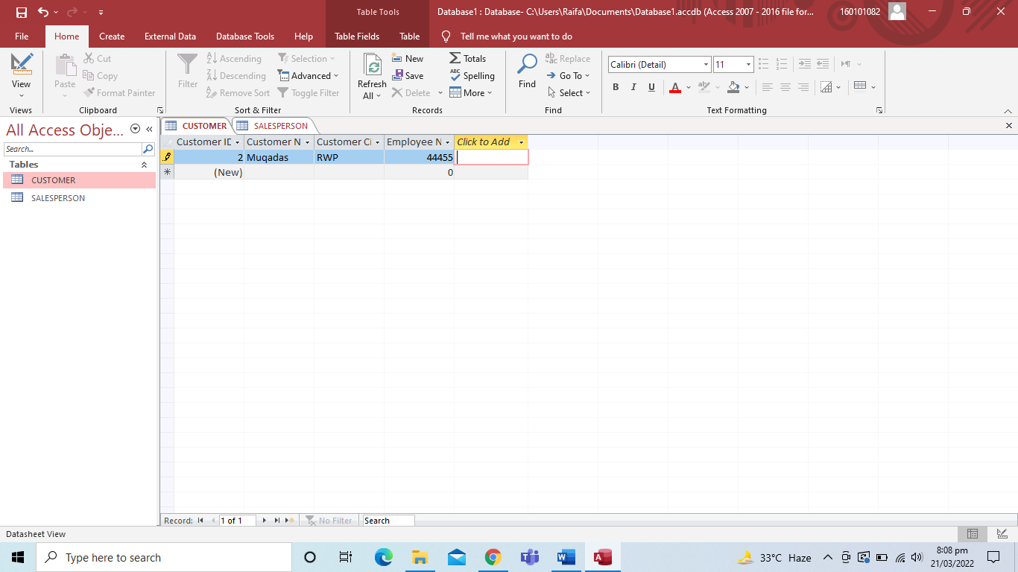

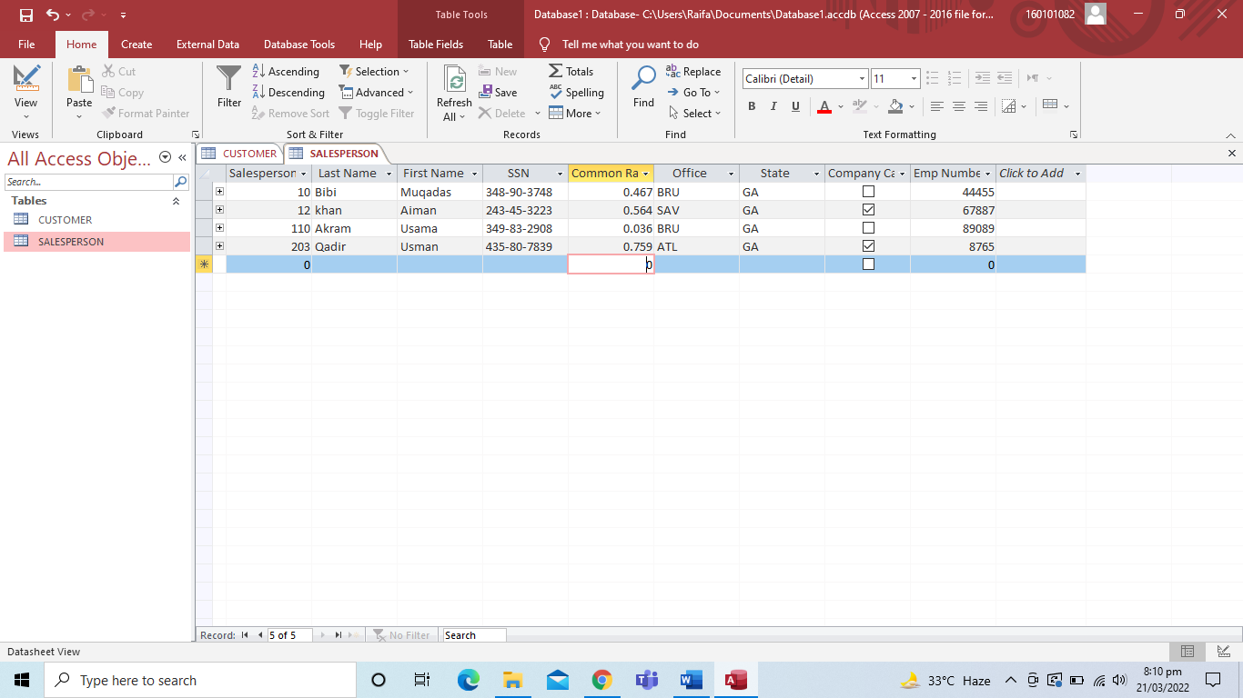

1. Sort the data according to the Employee Name and Customer Name.

